**ASSIGNMENT-2**

**TEAM ID: PNT2022TMID06631**

|  |  |
| --- | --- |
| **ASSIGNMENT DATE** | 19.09.2022 |
| **STUDENT NAME** | KODEESWARAN M |
| **STUDENT ROLL NUMBER** | 61072011903 |
| **MAXIMUM MARKS** | 2 |

PHARMA SALES

Challenge :-

Upload the dataset to Cognos Analytics, preparethe data, explore and Create Interactive Dashboard

Task 1: Sales By Customer. Task 2: Sales By Location.

Task 3: Sales By Sales Representative.

Task 4: Received Inventory From Supplier

Task 5: Inventory Stock for Warehouse Supplier Task 6: Sales Trend

Task 7: Monthly Sales

Task 8: Actual and Received Inventory by Month

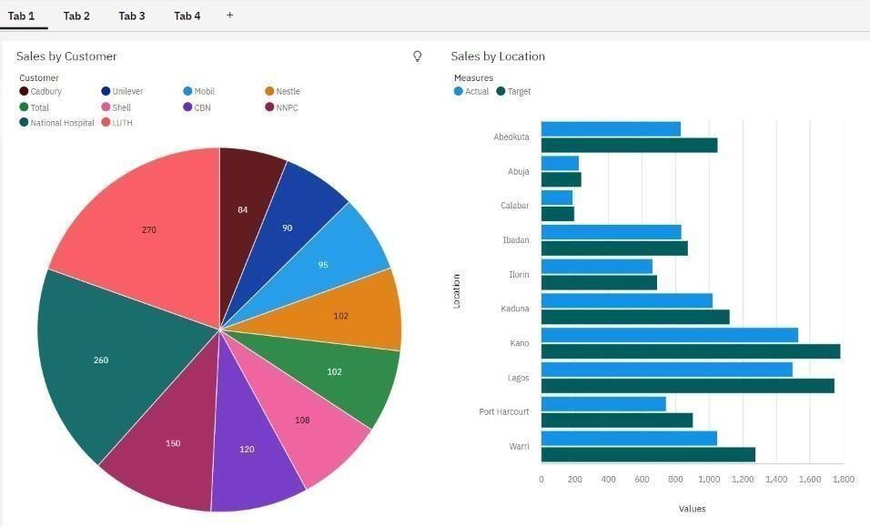

TASK-3

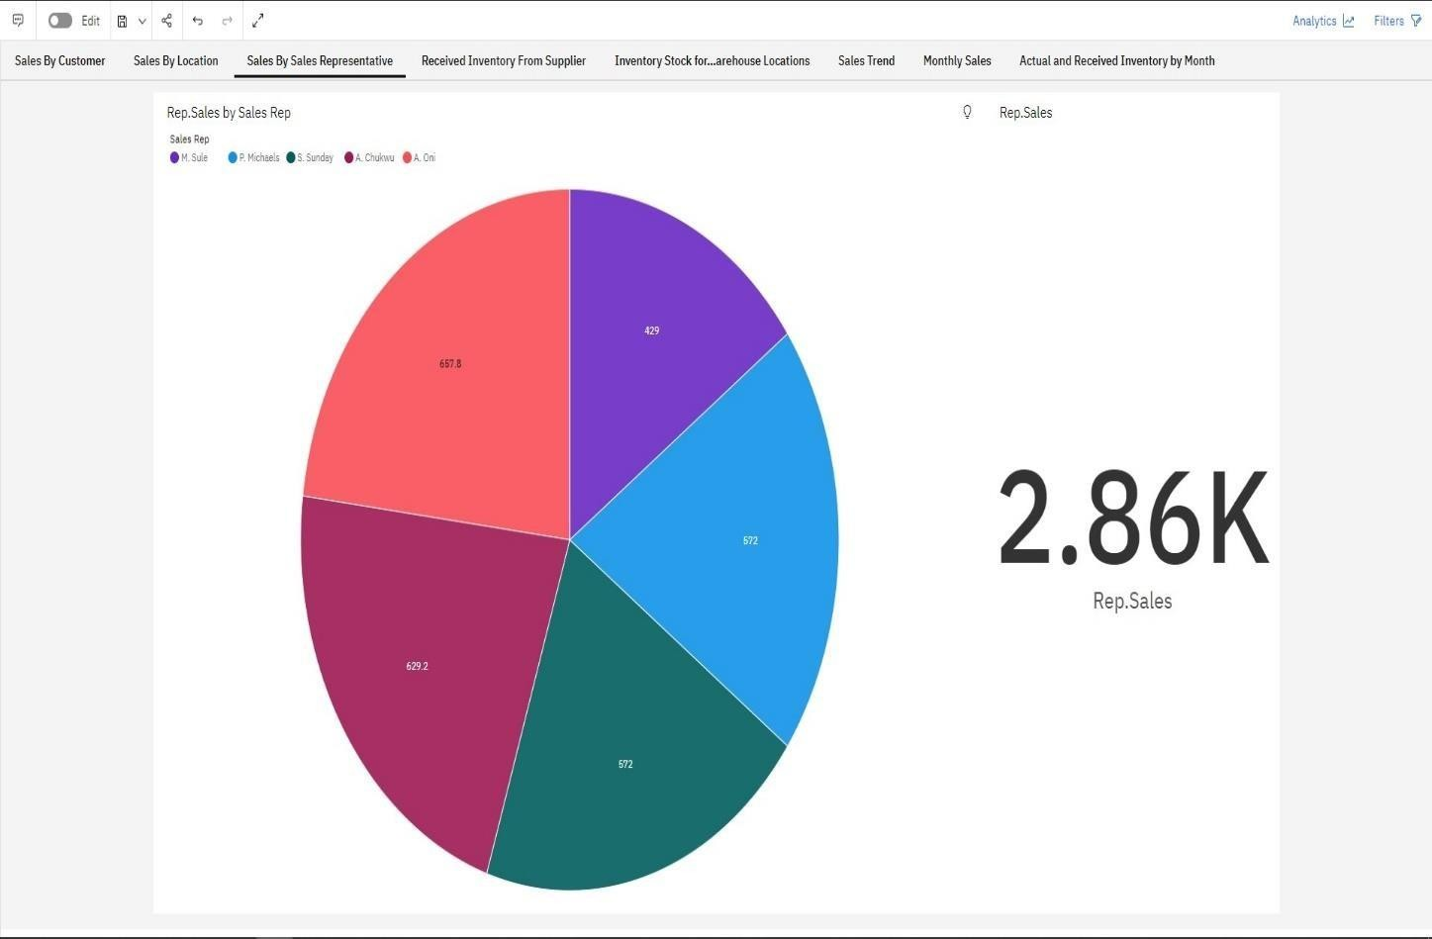

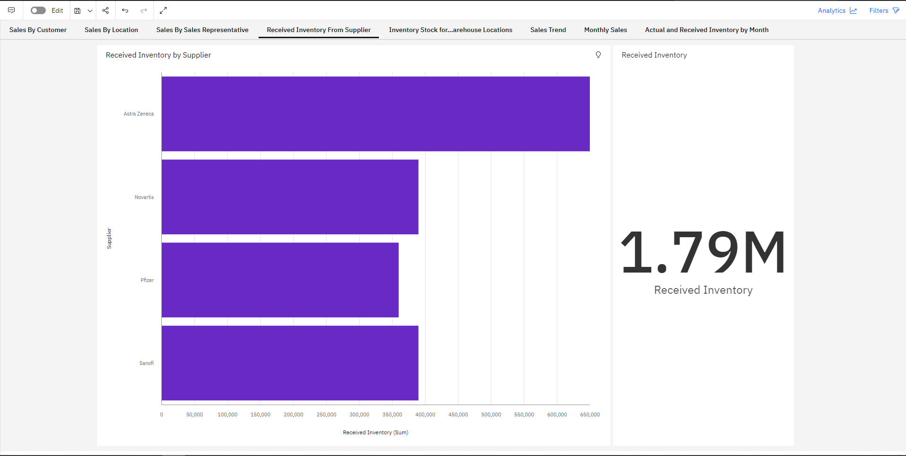

TASK-5 & TASK-6

